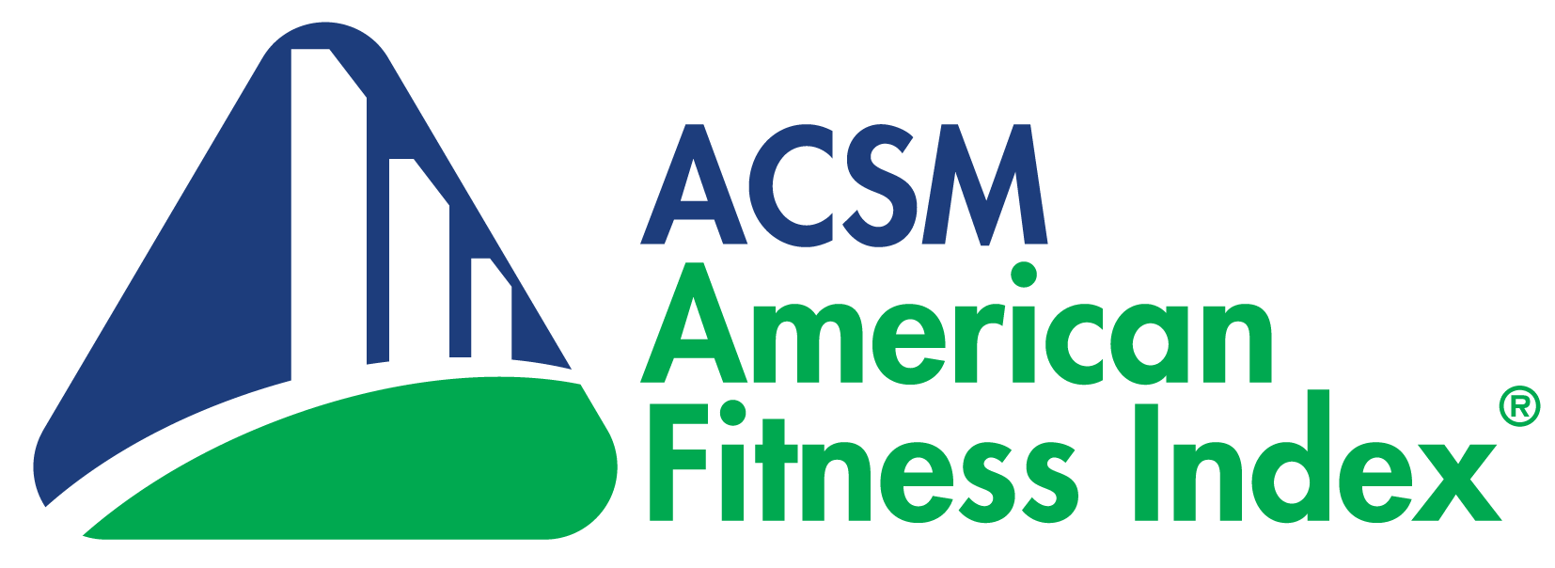

Active Transportation Op-ed Template

Walking and Biking are a Win, Win, Win for [INSERT CITY NAME HERE]
Safety is Key for Promoting Active Transportation

Walking, biking, and wheelchair or stroller rolling, also known as active transportation, has important benefits for communities around the globe, including economic benefits for people and communities, improved mental and physical health, and reduced pollution. In some areas, active transportation can replace motor vehicle use entirely. More commonly, walking or biking can be combined with cars or public transportation to replace parts of trips with active transportation.

The American Fitness Index, an annual ranking of the fitness of the 100 largest cities includes several active transportation indicators including residents walking or biking to work, using public transportation, Walk Score and Bike Score, proximity to local parks, pedestrian fatalities, and having a Complete Streets policy that guides infrastructure development. This data can help our city officials understand current walking and cycling behaviors and guide funding and city planning accordingly.

[For ranked cities, use the Fitness Index data to share local information relevant to active transportation. For example, you could use Fitness Index data to finish these sentences: In [INSERT CITY NAME], only [X%] of resident report walking or biking to work and only [X%] report using public transportation. We also see [X] pedestrian killed annually per 100,000 residents and that is unacceptable for [INSERT CITY NAME].

For smaller communities that are not included in the Fitness Index, use local data or county level data available from local health departments, transportation departments, or pedestrian and bicycling advocacy groups.

For all communities, this section could highlight areas where the community is doing well and draw attention to areas for improvement. The American Fitness Index and Smart Growth America/Complete Streets both have resources to promote community efforts to improve both the built environment and individual behaviors that promote walking and cycling.]

The cost of implementing infrastructure to support walking and cycling is often cited as a local barrier, but individuals and communities can benefit economically from increased active transportation. Communities that develop infrastructure and policies to promote walking and cycling experience direct and indirect benefits. These benefits include increased residential and commercial property values as well as the fact that people who are walking or biking are more likely to visit businesses along their route. Depending on the location and nature of the project, implementing active transportation can have a positive cost-benefit ratio and promote job creation.

In addition to the economic benefits, there are clear health and environmental benefits to walking and biking more. Beyond the influence on body weight, people who walk or cycle for transportation have a lower risk of diabetes and hypertension as well as death from cardiovascular diseases. Estimates suggest that even a small decrease in vehicle miles traveled by increasing walking and cycling could lead to reductions in particulate matter and greenhouse gas production which are linked to global warming and health problems, including pulmonary and cardiovascular diseases, contributing to 200,000 deaths per year.

Encouraging people to use active modes of transportation requires an environment that is safe for pedestrians and cyclists. Infrastructure improvements and laws favoring the safety of pedestrians and cyclists over the convenience of drivers are important for changing a community’s mindset. In fact, cities that have the highest use of active transportation also have a built environment that supports getting around without a car.

Given the economic, health, and environmental benefits, walking, biking, and wheelchair rolling is a win, win, win for our community. Across the country, cities large and small are funding and implementing infrastructure and policies to make them safer and more convenient for pedestrians and cyclists. Everyone benefits from a community that supports active transportation and we can’t afford not to take steps in that direction. It’s time to make our environmental, economic, and physical health a priority in [INSERT CITY NAME HERE] by supporting active transportation!

[NAME]
[TITLE, Affiliate or component name]
[CONTACT INFORMATION]

