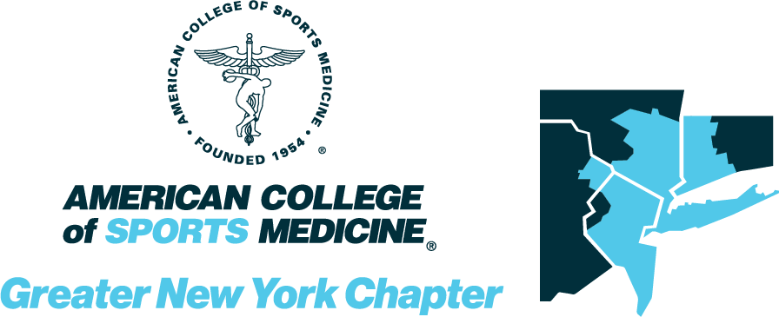

GNYACSM 2024
Abstract Submission Information

GNYACSM General Abstract Submissions
&
GNYACSM Abstracts for the President’s Cup Competition

Abstracts Due March 22th, 2024, at 11:59 EST

Abstract Submission Link: https://digitalcommons.wku.edu/cgi/submit.cgi?context=ijesab

GNYACSM Abstract Submission Instructions
GNYACSM Annual Spring Meeting and Conference.
All members and those joining the Greater New York Chapter of the American College of Sports Medicine (GNYACSM) are invited to submit abstracts for presentation in our student research award competition.

Please follow the general and/or student research award-specific instructions for submission.

General Abstract Submission Instructions
- All abstract submissions are required in electronic format and all research will be presented at the conference on April 20, 2024. See below for student award competition specifics.
- Each individual is permitted to be the first author on only one abstract, but may co-author several abstracts.
- The first author is considered a presenter and must present the abstract at the meeting.
- At least one of the authors must be a member of the GNYACSM.
- If one of the authors is a Fellow of the American College of Sports Medicine (ACSM), the letters FACSM should follow their name.
- All abstracts (maximum of 2000 characters without spaces) will be published in the program as submitted. Please check for spelling errors prior to submission.
- Abstracts should not have been published previously in any other printed or electronic format as beginning this year, abstracts will be published in the International Journal of Exercise Science. Publishing will be delayed so authors can also submit their abstracts to the national ACSM if they so choose.
- Abstract subheadings should follow ACSM requirements: purpose, methods, results, and conclusions.
- Presenting at GNYACSM does not preclude submitting the same abstract for presentation at an ACSM national meeting.
- Keep a copy of the abstract for your records.
- Following submission of an abstract, an electronic email confirmation will be sent to the applicant and co-authors (if co-author emails are provided). Email notification of acceptance and presentation information will be sent following submission from our GNYACSM Abstracts and Awards member, Alex Rothstein. If you do not receive the email notification, check that you included the correct email address free of spelling errors or check your junk mail or SPAM folders. You can contact the GNYACSM Abstracts and Awards members, if you believe you did not receive an email confirmation, see details below.
- If the submitted abstract does not adhere to the International Journal of Exercise Science guidelines authors will be allowed one week to correct and revise. The abstract will not be published if all corrections are not addressed. However, abstracts still may be presented at the conference.
- All accepted submissions are expected to be presented at the regional conference.

If you want to participate in the President’s Cup, please see additional information and requirements below.

Overview
The President’s Cup is a research poster competition held annually during the national ACSM Annual Meeting. The President’s Cup is organized with the assistance of the Student Affairs Committee and ACSM national staff. Each regional chapter will have their own “Regional President’s Cup” and will select one student based on the quality of research presented at their regional chapter annual meeting and this student will represent the chapter in the President’s Cup competition at the national ACSM Annual Meeting. A panel of judges, using an established judging rubric, will select the ultimate winner.

Mandatory Requirements
a. Each regional winner must be a current member of both the national ACSM organization and his/her affiliated ACSM regional chapter organization.
b. Each regional winner must be a student enrolled in a program at the time of the regional chapter meeting. However, if the student were to graduate before the ACSM Annual Meeting, they are still eligible for the national-level competition. Note: students can be either undergraduate or graduate at the national-level competition, but regional chapters can limit to just graduate students if they wish.
c. Each regional winner must be able to attend the national ACSM Annual Meeting in Boston, MA (May 28 – June 31, 2023) for the national president’s cup competition.
d. Current Student Affairs Committee and/or BOT members are NOT eligible for the President’s Cup competition.
e. Past President’s Cup regional and national winners are NOT eligible for the President’s Cup competition.
f. Each regional winner will be required to deliver a poster presentation at the national ACSM Annual Meeting. Individuals who have won their regional competition with an oral/slide/podium presentation will be required to reformat the same presentation into a poster. Thus, winners will need to plan accordingly.
g. The type of project conducted by the student must align with the mission of ACSM, which is to: “…advance and integrate scientific research to provide educational and practical applications of
exercise science and sports medicine.”

Student Research Award Competition Specific Instructions
Abstract submissions that do not follow the submission guidelines may be
rejected. Abstracts that do not meet scientific or editorial standards will not be accepted.
1. The type of research conducted by the student must align with the mission of ACSM, which is to:
“…advance and integrate scientific research to provide educational and practical applications of
exercise science and sports medicine.” Examples of topics (aligned with National) are included
below, for both applied and clinical.
2. All wording should be in English utilizing; correct spelling, grammar, and proper contextual word
usage. All acronyms are required to be first fully defined at least once within the body of the
abstract prior to any other uses (the title is unnecessary). No brand names are permitted within
the submitted abstract. All abstract submissions must follow formats demonstrated in the
examples below.
3. There is a strict 2000-character limit for the abstract’s main body (not including
spaces / title/subheadings/author block).
4. The title of the abstract is limited to 15 words.
5. The body of the abstract MUST include the following sections: PURPOSE, METHODS,
RESULTS, CONCLUSION (see the example abstracts below for clarification)
6. Include the names, institutional affiliations, and emails of all authors. Names should include full
first name, middle initial (optional), & full last name. DO NOT list degrees, certifications, or
departments. LIST ALL ACSM Fellow(s), sponsorship, funding, grants, subsidies, or ANY
conflict(s) of interest.
7. Reference citations, photos, illustrations, graphs, tables, charts, etc. are NOT permitted within
the abstract’s text, but should be available upon Research Committee request or in the slide
presentation.
Award Selection Criteria for Abstract Evaluation and Presentation
*These judging criteria are consistent with those used
to judge the national-level competition*
1. Significance: How well the project relates to the mission statement of ACSM, which is to “advance
and integrate scientific research to provide educational and practical applications of exercise
science and sports medicine.”
2. Innovation: The novelty of the project, especially relating to the use of new methodologies,
studying under-investigated populations and/or addressing emerging problems relating to
exercise and sports medicine.
3. Research Design: The ability of the methodologies used to address the research question and
hypothesis. Additionally, the appropriate use of experimental design and statistics to test
the hypothesis.
4. Ability to Respond to Questions: Ability of the student to demonstrate knowledge of the literature
related to their field of study as well as demonstrate critical thinking for future studies.
5. Presentation Skills: Clarity of the presentation and description of research project.
Conference Awards for Abstract Presentations
ALL presenters will each receive a full complement of CECs / CEUs for the entire day’s
attendance along with their given presentations. Additionally, presenters will receive a
one-year ACSM-GNYRC Membership. The regional conference registration fee will be waived for
all scheduled invited attending presenters with free breakfast & lunch provided on-site
All questions regarding the abstract submission or the student research award competition should be directed to:
Alex Rothstein GNYACSM Research Chair Email: arothste@nyit.edu

GNYACSM Original Research Abstract – Please do not change any fonts, font sizing, or spacing!

This is My Abstract Title – notice the appropriate uppercase

AUTHOR B. ONE, AUTHOR C. TWO, FACSM, & AUTHOR D. THREE First then Last name, all upper-case

Laboratory Name; Department; University; Location, STATE

Category: Undergraduate/Masters/Doctoral (select one & delete others)

Advisor / Mentor: Last Name, First Name (email address) – do NOT hyperlink the email

ABSTRACT
Begin with a short sentence or two with background on the topic. Please include a PURPOSE: describing the intent of the study. METHODS: how the study was conducted. RESULTS: findings of the study should be here. CONCLUSION: Reference lists are not generally included.

Please note the abstract headings (they must be included, bolded, and uppercase). Do NOT change the justification (alignment), font type, font size, or spacing (abstracts should be single-spaced).

All abstracts (maximum 2000 characters without spaces and/or one page) will be published in the program as submitted.

Direct any questions about this process to Alex Rothstein (arothste@nyit.edu) to ensure your abstract is formatted properly and submitted successfully.

Once finished, be sure to delete anything in red. Once the following is read, please delete it as well:

This abstract has not been presented and will not be presented at any other conference, other than National ACSM. Abstract submission assumes the study has been approved by an appropriate IRB.

GNYACSM Clinical Case Abstract – Please do not change any fonts, font sizing, or spacing!

This is My Abstract Title – notice the appropriate uppercase

AUTHOR B. ONE, AUTHOR C. TWO, FACSM, & AUTHOR D. THREE First then Last name, all upper-case

Laboratory Name; Department; University; Location, STATE

Category: Undergraduate/Masters/Doctoral (select one & delete others)

Advisor / Mentor: Last Name, First Name (email address) – do NOT hyperlink the email

ABSTRACT
Please include a CASE HISTORY: insert text. PHYSICAL EXAM: insert text. DIFFERENTIAL DIAGNOSES: List/discuss 3-5. TESTS & RESULTS: Lab(S), X‐ray(S), etc.). FINAL DIAGNOSIS: insert text. DISCUSSION: insert text. OUTCOME OF THE CASE: insert text. RETURN TO ACTIVITY AND FURTHER FOLLOW-UP: insert text. Reference lists are not generally included.

Please note the abstract headings (they must be included, bolded, and uppercase). Do NOT change the justification (alignment), font type, font size, or spacing (abstracts should be single-spaced).

All abstracts (maximum 2000 characters without spaces and/or one page) will be published in the program as submitted.

Direct any questions about this process to Alex Rothstein (arothste@nyit.edu) to ensure your abstract is formatted properly and submitted successfully.

Once finished, be sure to delete anything in red. Once the following is read, please delete it as well:

This abstract has not been presented and will not be presented at any other conference, other than National ACSM. Abstract submission assumes the study has been approved by an appropriate IRB.

Access the International Journal of Exercise Science Conference Proceedings site at: https://digitalcommons.wku.edu/ijesab

Click on “Submit Abstract” (left side menu)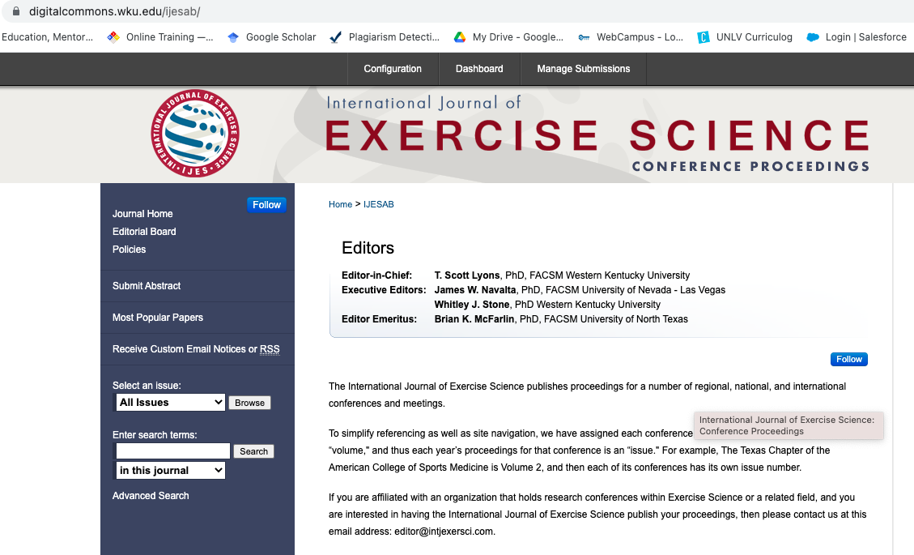

Have your title (in Title case), author emails, and GNYACSM abstract template saved in a known location. Click “Continue”

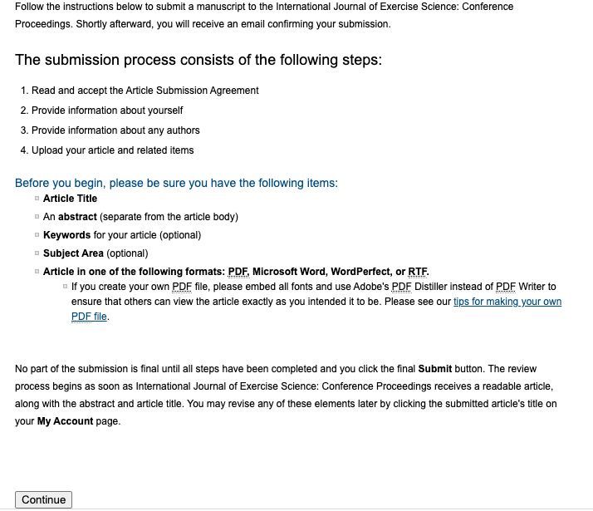
Read the Article Submission Agreement and click “Accept”
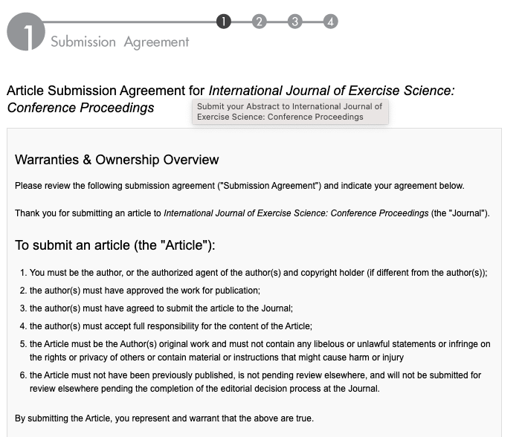
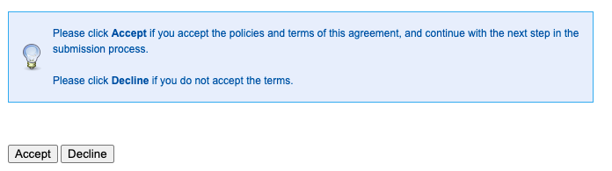

Enter your First/Given name, Last/Family name, and Institutional Affiliation.

**If you are a Fellow of the American College of Sports Medicine, enter FACSM in the suffix dialogue box.

Click “Continue”

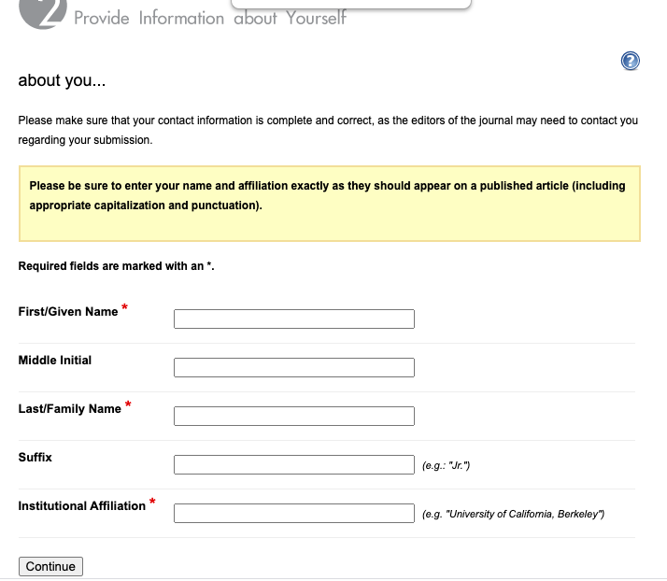

Click “Add author” to include coauthors.

Then add the required information and click “Add to list of authors.”
**If a coauthor is a Fellow of the American College of Sports Medicine, enter FACSM in the suffix dialogue box.

Repeat until all coauthors are included.

Then click “Continue”
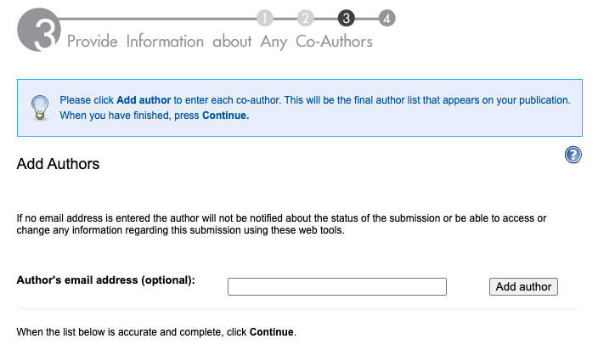

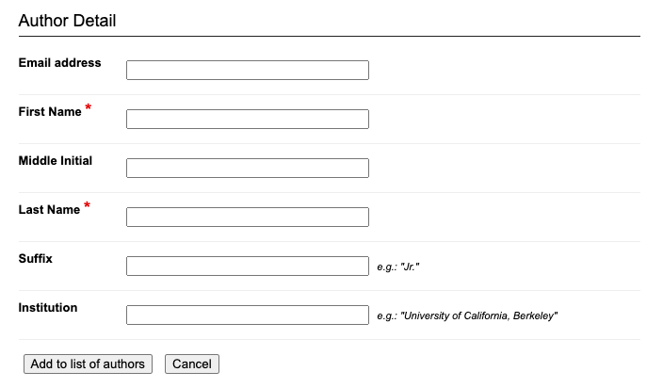

Enter the article title (it is not necessary to enter a short title, key words, or select a subject area)
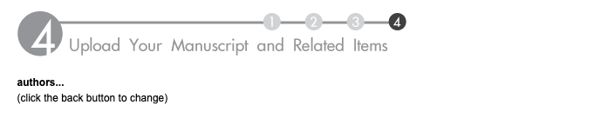

For submission type, select Greater New York ACSM Abstract

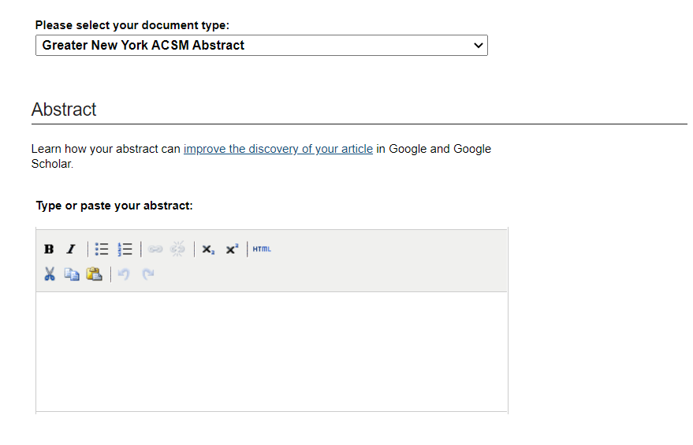
Paste your abstract into the Abstract dialogue box.

You do NOT need to include a cover page footnote.

Upload the template containing your GNYACSM abstract using the Full Text of Submission radio button.
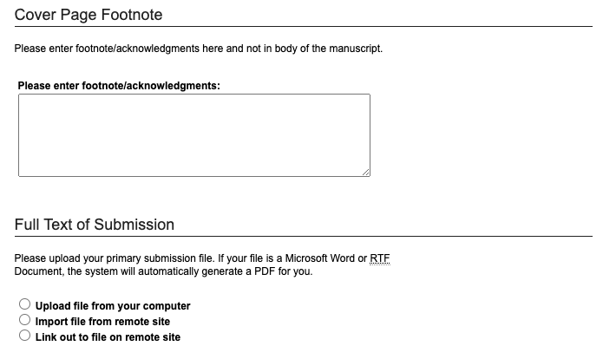
You do NOT need to include a cover letter.
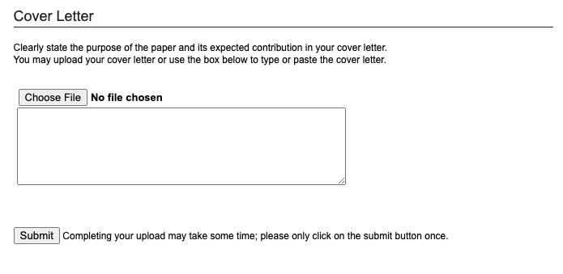
Finally, click “Submit” one time.
You will receive an email confirmation that your abstract has been submitted.

