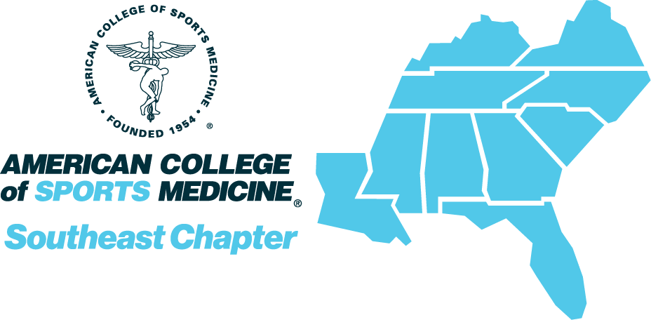

SEACSM Leadership and Diversity Training Program
2023 Award Application

The purpose of the SEACSM Leadership and Diversity Training Program (LDTP) is to encourage student members from minority groups underrepresented in the sciences to participate in activities that will lead to successful mentored experiences at the Annual Meeting, enhanced pathways to degree completion and career opportunities, and increased SEACSM and ACSM service. The LDTP awards are for up to $599 each. Students may participate in the program for one year.
LDTP recipients will be matched with a professional SEACSM member who will assist the student with setting goals, preparing for attending the Annual Meeting, providing active mentorship at the meeting to connect the student with potential academic, research, and service opportunities, and guide the student through next steps to achieve their educational/professional goals after the meeting.

Eligibility:
All applicants must meet the following criteria:
- Be a member of a racial or ethnic minority group that is underrepresented in the sciences according to NIH criteria: American Indian or Alaska Native, Black or African American, Hispanic or Latino, and Native Hawaiian or Other Pacific Islander.
- Be a citizen, citizen national or permanent resident of the U.S.
- Be currently enrolled in a program in kinesiology, exercise science, sports medicine, epidemiology, or a related field.
- Have a financial need for the award.

Application instructions:
All application materials must be submitted by 5:00 pm ET on December 16, 2022. The application includes an online form and a written recommendation.
A link to the online application form is available at the SEACSM LDTP web page: https://www.acsm.org/membership/regional-chapters/acsm-chapters/southeast/students/seacsm-leadership-diversity-training-program

The form includes:
- Applicant information, including eligibility and education history
- Responses to the following “essay” questions:
  - Why you are applying for the SEACSM LDTP program
  - Your reasons for wishing to attend the SEACSM Annual meeting
  - Your goals for the mentoring experience
  - How the LDTP award will help you and your plans as a student and professional
  - How you think this experience will advance your academic and scholarly goals
  - Your interest in greater involvement with SEACSM and ACSM in the future
  - The reason(s) for your financial need to attend the SEACSM Annual Meeting

Additionally, you must provide one recommendation which will be submitted separately by the recommender. This includes:
- Evaluation form
- Letter of recommendation

Review process
- Your application will be reviewed by a panel of SEACSM professional members.
- Evaluation is based on
  - meeting the application criteria
  - the completeness and professionalism of your application
  - demonstrating your reasons and goals for the program in your essay
  - the support of your professional reference
  - submission of all application materials by the deadline
- Decisions will be communicated to applicants by January 13, 2023.

SEACSM Leadership and Diversity Training Program
LETTER OF RECOMMENDATION

The purpose of the SEACSM Leadership and Diversity Training Program is to encourage candidates who are SEACSM student members from minority groups underrepresented in the sciences to participate in activities that will lead to successful mentored experiences at the Annual Meeting, enhanced pathways to degree completion and career opportunities, and increased SEACSM and ACSM service. The LDTP awards are for up to $599 each.
In the LDTP program, participants will be matched with a professional SEACSM member who will help the student set goals and prepare for attending the Annual Meeting, provide active mentorship at the meeting to connect the students with potential academic, research, and service opportunities, and guide the student through next steps to achieve their goals after the meeting.
Please note that the applicant will be evaluated based on your responses to the items below and your letter of support, as well as their application materials. This evaluation is important for determining LDTP awards.
Please send your completed evaluation form and letter of recommendation via email to SEACSM Past-President Matt Green at jmgreen@una.edu by 5:00 pm ET on December 16, 2022. In the subject line please write the applicant’s name and “LDTP.”

SEACSM Leadership and Diversity Training Program
LETTER OF RECOMMENDATION

Applicant’s Name: Date of Evaluation:

Recommender’s Name: Recommender’s Institution:

Please rank the following as 5=highest, 0=lowest
- Applicant’s academic and/or scholarly achievement, including work ethic, quality, and productivity
- Applicant’s leadership skills and experience
- Applicant’s long-term interest in an academic, research, or other ACSM-related career
- Applicant’s potential to contribute to SEACSM and ACSM
(e.g., presentations, service, other leadership roles)
- Importance of LDTP award for applicant to attend the SEACSM Annual Meeting

Signature Date

Please write a letter including the following:
Applicant’s Name
Your Name
Title/Position/Institution
Your involvement with SEACSM and ACSM

Please provide the following information:
- How long and in what capacity have you known the applicant?
- Describe the quality of the applicant’s academic and/or scholarly work.
- In what ways is the applicant a good candidate for the LDTP program?
- How do you think the applicant would benefit from attending the SEACSM Annual Meeting?
- Evaluate the applicant’s interest and long-term potential to contribute to SEACSM and ACSM.

Please rate the applicant according to:
- General knowledge
- Leadership skills
- Persistence toward goals
- Maturity
- Professionalism

