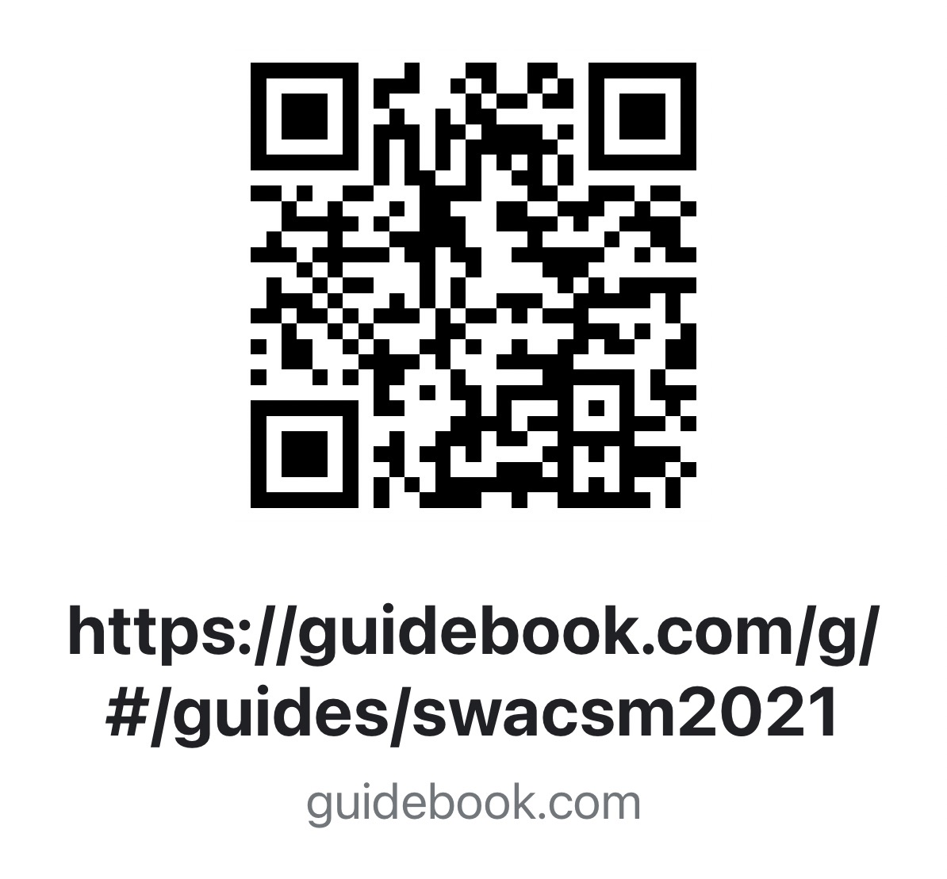

FRIDAY OCTOBER 27, 2023
Event | Time | Speaker and Topic | Location
Registration | 7:30 a.m.-5:00 p.m.
General Session  DB Dill Lecture 1 | 9:15-10:45 A.M. | Born to move: The Effect of Evolutionary Mismatch on Biomechanics and Musculoskeletal Injuries  Irene Davis, PhD, PT, FACSM, FAPTA, FASB | Pacific Ballroom III & IV
Undergraduate Student Research Competition | 11:00 a.m.-12:30 p.m. | Moderator: James Navalta, PhD | Emerald Bay
Symposium 1 | 11:00 a.m.-12:30 p.m. | Best Practices for Reproducible and Transparent Undergraduate and Graduate Research  Zachary Zenko, PhD, FACSM  Vanessa R. Yingling, PhD, FACSM  Jafrā D. Thomas, PhD, MPH, MA | Pacific III
Symposium 2 | 11:00 a.m.-12:30 p.m. | Sweat Testing for Heat Safety  Khalil Lee, PhD, CSCS | Pacific IV
LUNCH | 12:30-1:45 p.m. | See Guidebook App or website for nearby restaurants
Graduate Student Research Competition | 1:45-3:15 p.m. | Moderator: Jeffrey Bernard, PhD | Emerald Bay
Symposium 1 | 1:45-3:15 p.m. | Muscle Fiber Phenotype as a Key Driver of Metabolic Responses in Sports, health and Disease  Nathan Serrano, MS  James Bagley, PhD  Christos Katsanos, PhD | Pacific III
Symposium 2 | 1:45-3:15 p.m. | Preparing the Future Generation of Army Officers  Zachary Zeigler, PhD  Anthony Acevedo, PhD | Pacific IV
Symposium 1 | 3:30-4:30 p.m. | New Insights About the Consequences of the Exposure to Tobacco Products on Cardiac and Skeletal Muscle  Leonardo Nogueira, PhD  Ellen C. Breen, PhD  Yoshitake Cho, PhD | Emerald Bay I & II
Faculty Social | 4:00-5:00 p.m. | Network and Connect  *Limited to Faculty and Professionals* | Pacific I & II
Poster Session 1 | 5:00-7:00 p.m. | Pacific I & II
JEOPARDY | 7:00-8:30 p.m. | Moderators  Matt Lee, Ph.D.  James Navalta, Ph.D. | Pacific III & IV

SATURDAY OCTOBER 28, 2023
Event | Time | Speaker and Topic | Location
Registration | 7:30 a.m.-12:30 p.m.
Student/Faculty Mentorship Breakfast | 8:00-9:00 a.m. | Establishing Meaningful Connections for Personal and Professional Development | Pacific III
Symposium 2 | 8:00-9:00 a.m. |  | Pacific IV
General Session  Founder’s Lecture | 9:15-10:45 a.m. | Tactical Strength and Conditioning: What You Don’t Learn in Textbooks  J. Jay Dawes, PhD, CSCS*D, NSCA-CPT*D, TSAC-F, FNSCA | Pacific III & IV
Symposium 1 | 11:00 a.m.-12:30 p.m. | Pedagogies and Teaching Practices in the Exercise Science Classroom: An exploration in sense of belonging, involvement, and co-curricular activities  Zakkoyya H. Lewis, PhD, ATC, ACSM EP-C, EIM  Amanda M. Rymal, PhD  Matthew C. Jackson, MS, CSCS, USAW  Sarah L. Dunn, PhD  Holli Rosas, MS  Gustavo Donis-Castro | Pacific III
Symposium 2 | 11:00 a.m.-12:30 p.m. | Augmented and Virtual Reality for Gait and Balance Rehabilitation: Benefits, Challenges, and Future Outlook  Jacob W. Hinkel-Lipsker, PhD  Talin Bakalyan  Gwendolyn Retzingeer  Joshua Vicente  Wendy Pham | Pacific IV
Poster Session 2 | 12:30-2:30 p.m. |  | Pacific I & II

